IT TOOLS

**\*What is a repository?**

A repository contains all of your code, your files, and each file's revision history. You can discuss and manage your work within the repository.

**\*Steps to create a repository**

**Step 1** : In the upper-right corner of any page, select + , then click **New repository**.

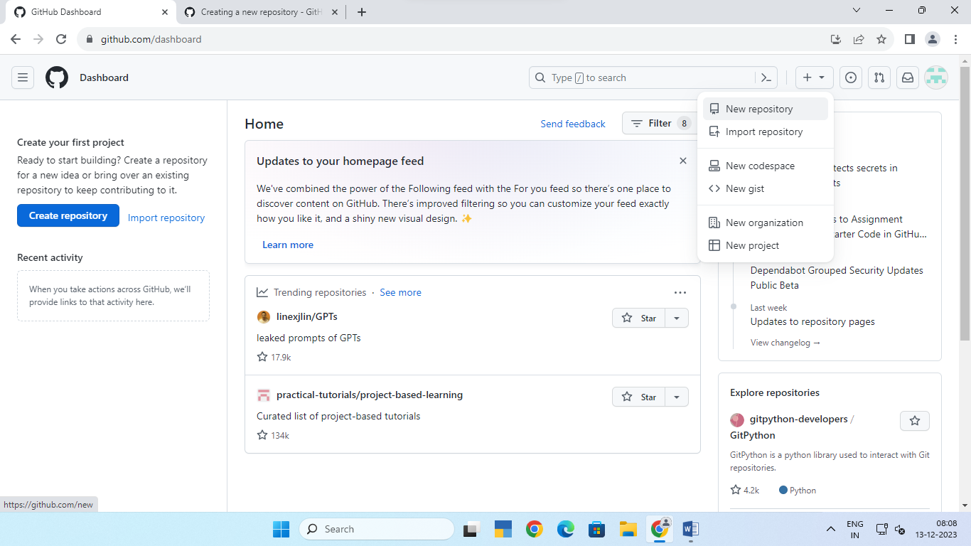

**Step 2** : Use the **Owner** dropdown menu to select the account you want to own the repository.

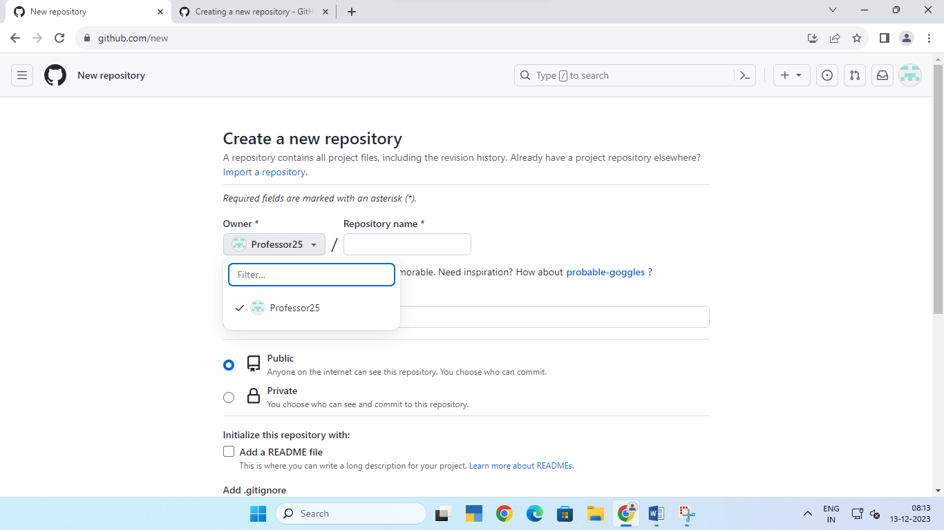

**Step 3** : Type a name for your repository, and an optional description.

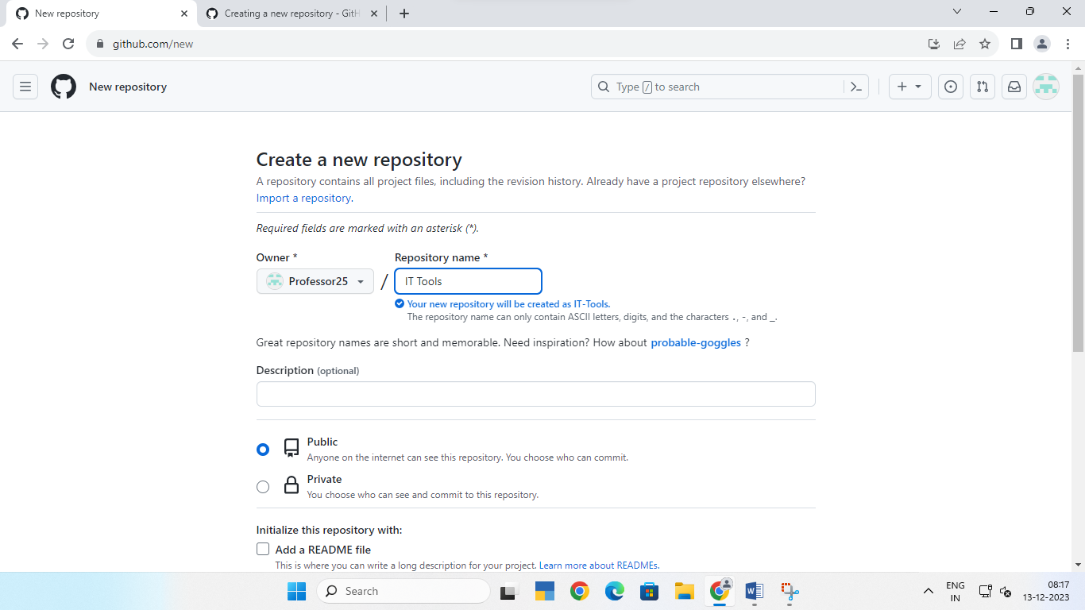

**Step 4** : Choose a repository visibility

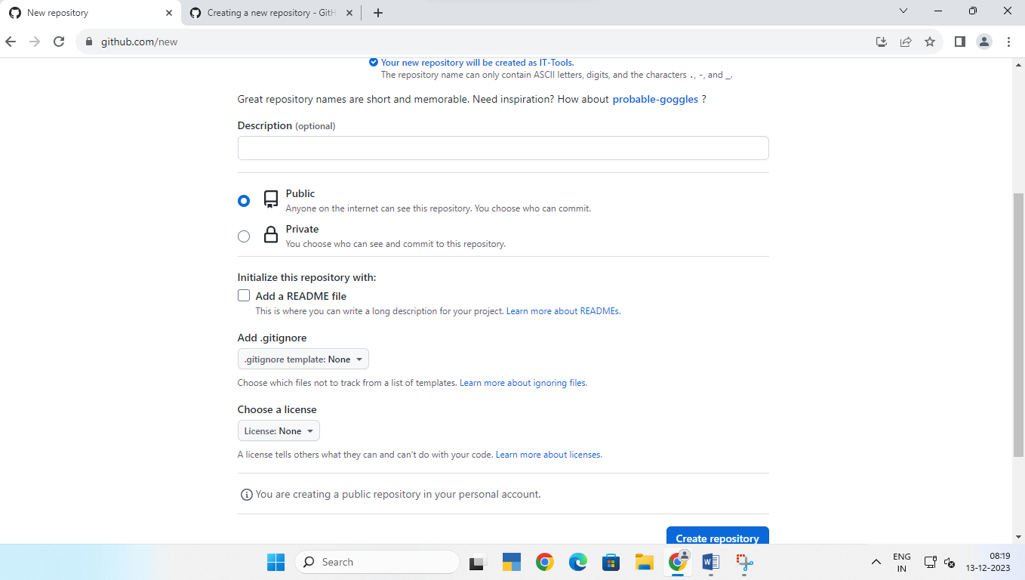

**Step 5** : You can create a README, which is a document describing your project.

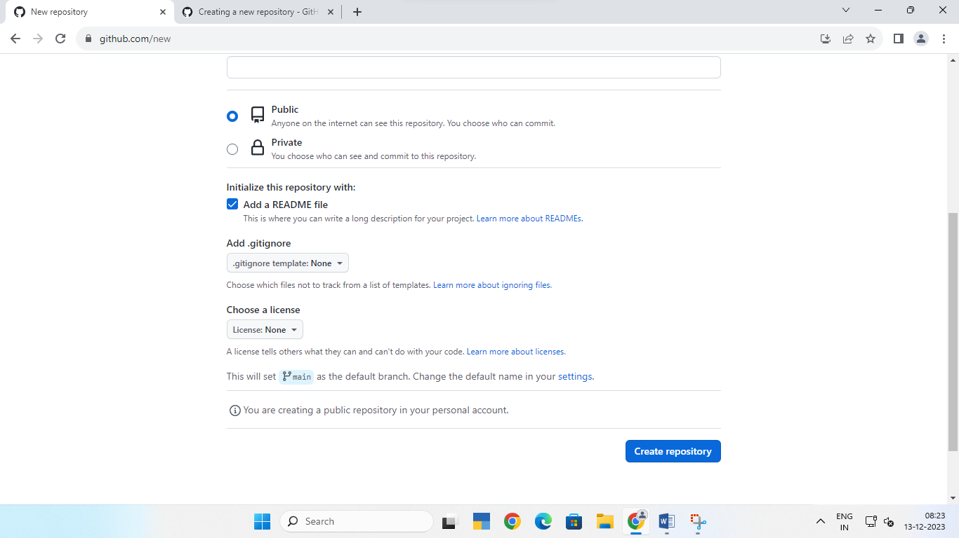

**Step 6** : Click **Create repository**.

